1 . DESIGN A SYSTEM ARCHITECTURE FOR MULTI-ACCESS EDGE COMPUTING TO REDUCE LATENCY IN SMART TRAFFIC APPLICATIONS.
1. Introduction
Smart traffic management requires continuous monitoring of vehicles, traffic density, road conditions, and accidents. Conventional cloud-based traffic systems send all collected data to a remote cloud server for processing. This increases communication delay and consumes large network bandwidth.
To overcome this problem, a Multi-access Edge Computing (MEC) architecture is proposed. In MEC, computation and storage facilities are placed close to the traffic sources, such as roadside units, cameras, and vehicles. The proposed system processes critical traffic information at the edge and uses the cloud for long-term storage and large-scale analysis.
The main objective is to achieve low latency, faster traffic decisions, efficient bandwidth utilization, and intelligent traffic control.
2. Objectives
The proposed MEC-based smart traffic system has the following objectives:
- Reduce end-to-end communication latency.
- Monitor traffic conditions in real time.
- Detect congestion and abnormal traffic conditions.
- Perform traffic-data processing close to the vehicles.
- Dynamically control traffic signals.
- Reduce unnecessary transmission of raw data to the cloud.
- Provide scalability for large smart-city deployments.
3. Proposed System Architecture
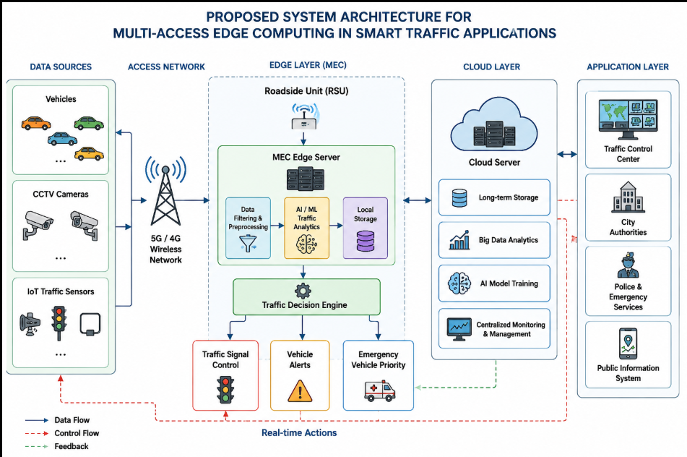4. Components of the Proposed System
4.1 Vehicles
Vehicles act as mobile data sources. They can provide information such as vehicle speed, position, direction, and traffic conditions.
4.2 CCTV Cameras
Cameras continuously capture road traffic. Video information can be processed by AI algorithms to identify vehicle density, accidents, and congestion.
4.3 IoT Traffic Sensors
Sensors are installed on roads to measure vehicle count, speed, road occupancy, and other traffic parameters.
4.4 5G Wireless Network
The 5G network provides high-speed and low-latency communication between vehicles, sensors, roadside units, and edge servers.
4.5 Roadside Unit
The roadside unit collects wireless information from nearby vehicles and sensors and forwards it to the MEC server.
4.6 MEC Server
The MEC server is the major processing unit. Instead of sending every data packet to a remote cloud, it performs local processing near the traffic source.
4.7 AI/ML Module
The AI module analyzes traffic information and identifies congestion, accidents, abnormal traffic patterns, and emergency situations.
4.8 Traffic Control System
The traffic controller uses the decisions generated by the MEC server to modify traffic signal timing.
4.9 Cloud Server
The cloud is used for long-term storage, historical traffic analysis, centralized monitoring, model training, and city-wide traffic management.
5. Working Principle
- Vehicles, cameras, and IoT sensors continuously collect traffic information.
- The collected information is transmitted through the 5G wireless network.
- The roadside unit receives the information from nearby devices.
- The data is forwarded to the MEC server.
- The MEC server performs filtering and preprocessing.
- The AI/ML module analyzes traffic conditions.
- If congestion is detected, the traffic decision engine calculates an appropriate response.
- Traffic signals are dynamically adjusted according to traffic density.
- Emergency vehicles can be given priority when required.
- Important processed information is transmitted to the cloud.
- The cloud maintains historical records and performs large-scale traffic analysis.
6. Latency Reduction
In a conventional cloud architecture, traffic information travels from the sensor to a remote cloud and then returns to the traffic-control system. This introduces transmission, propagation, processing, and backhaul delays.
In the proposed MEC architecture, the processing server is located near the traffic source.
The approximate end-to-end latency can be represented as:
T_total = T_sensor + T_wireless + T_backhaul + T_processing + T_propagation
For cloud processing:
T_cloud = T_sensor + T_wireless + T_cloud-backhaul + T_cloud-processing + T_cloud-propagation
For MEC processing:
T_MEC = T_sensor + T_wireless + T_edge-backhaul + T_edge-processing + T_edge-propagation
Since the MEC server is geographically closer:
T_edge-backhaul << T_cloud-backhaul
Therefore:
T_MEC < T_cloud
This makes MEC suitable for time-critical smart traffic applications.
7. Traffic Control Algorithm
START
↓
Collect traffic sensor/camera data
↓
Send data to MEC server
↓
Filter and preprocess data
↓
Calculate vehicle density
↓
Is congestion detected?
↓
YES ───────────── NO
↓ ↓
Increase green Maintain
signal duration normal timing
↓ ↓
Check emergency vehicle
↓
Send traffic-control decision
↓
Update traffic signals
↓
Store important data in cloud
↓
END
8. MATLAB Simulation
A MATLAB simulation is developed to compare cloud-based processing and MEC-based processing.
Simulation Parameters
Parameter | Value
Number of traffic packets | 1000
Average packet size | 20 kB
Cloud logical distance | 800 km
MEC distance | 2 km
Wireless transmission delay | 4–6 ms
MEC processing delay | 5–7 ms
Cloud processing delay | 25–35 ms
Traffic load | 10–100%

The simulation calculates the end-to-end latency for both cloud and MEC architectures.
MATLAB Method
The MATLAB program generates traffic packets and assigns transmission, propagation, backhaul, and processing delays. The total latency is calculated using:
Cloud Latency = Sensor + Wireless + Cloud Backhaul + Cloud Processing + Propagation
MEC Latency = Sensor + Wireless + Edge Backhaul + Edge Processing + Propagation
The program also evaluates latency under different traffic loads and generates graphs.
MATLAB Results to Discuss
The simulation produces:
- Cloud vs MEC average latency graph.
- Latency versus traffic-load graph.
- Cloud and MEC latency distribution.
- Vehicle-density versus traffic-signal green-time graph.
The expected result is that the MEC architecture provides lower latency than cloud-only processing, especially when the traffic load increases.
9. Performance Comparison
Parameter | Cloud-Based System | Proposed MEC System
Processing location | Remote cloud | Near traffic source
Latency | High | Low
Backhaul traffic | High | Reduced
Real-time response | Moderate | Excellent
Traffic control | Slower | Faster
Scalability | High | High with multiple edge nodes
Long-term storage | Excellent | Limited
AI processing | Cloud-based | Edge + Cloud
10. Advantages
- Low communication latency.
- Real-time traffic monitoring.
- Faster congestion detection.
- Faster accident response.
- Reduced cloud bandwidth consumption.
- Dynamic traffic-signal control.
- Supports emergency vehicle priority.
- Scalable for smart-city applications.
- Combines edge processing with cloud analytics.
11. Limitations
- Requires deployment of MEC servers.
- Edge infrastructure increases initial cost.
- Edge nodes require maintenance.
- Security must be carefully managed.
- Heavy computation may overload an edge server.
- Multiple MEC nodes require proper coordination.
12. Improvements
The system can be improved by using:
- AI-based traffic prediction.
- Intelligent task scheduling.
- Load balancing between MEC servers.
- Secure communication and authentication.
- Edge-server redundancy.
- Advanced 5G/6G wireless technologies.
- Federated learning for distributed traffic intelligence.
13. Conclusion
The proposed MEC-based smart traffic architecture provides an efficient solution for real-time traffic management. By moving computation closer to vehicles and roadside sensors, the system significantly reduces communication and processing latency. The cloud is retained for long-term storage and large-scale analytics.
Therefore, the combination of 5G + MEC + AI + IoT provides a suitable architecture for intelligent, low-latency, and scalable smart traffic applications.

